|  |  |
| --- | --- |
|  | **FPT ACADEMY INTERNATIONAL**  **FPT – APTECH COMPUTER EDUCATION** |

**Centre Name: ACE-HCMC-FPT.**

**Address: 590 Cach Mang Thang 8, District 3, Ho Chi Minh City, Viet Nam.**

**Insurance online**

**Installation Guide**

|  |  |  |
| --- | --- | --- |
| **Supervisor:** | Mr. Hoang Duc Quang | |
| **Semester:** | 3 | |
| **Batch No:** | T1.2011.M0 | |
| **Group No:** | 3 | |
| **Team member:** | **Full name** | **Roll No.** |
| 1. | Do Tran Long | Student1287966 |
| 2. | Do Thanh Nam | Student1286087 |
| 3. | Le Ngan Tam | Student1288146 |
| 4. | Dinh Ngoc Minh Hieu | Student1285592 |

**Month: May Year:** 2022

1. **WORK PROCESS**
2. **Customer (Front-end) :**

Buyers can use system for:

* Before login:
* Customer View Insurance service
* Customer can view FAQs Insurance
* Customer can view About us Insurance
* Customer can view News Insurance
* Customer can view Policy Insurance
* Customer view Contact Insurance
* After login:
* Customer can Logout
* Customer can Register
* Customer View Insurance service and buy Insurance service
* Customer use Feedback
* Customer can view About us
* Customer can view FAQS
* Customer can view News
* Customer can view Policy
* Customer can view Contracts
* Customer can view Information

1. **Admin (Back-end)**

* Logout
* manage:

Admin can manager Insurance

+Add Insurance

+Edit Insurance

+Delete Insurance

+Details Insurance

* Admin can manager Insurance type(Add,edit,delete,details Insurance type)

+Add Insurance type

+Edit Insurance type

+Delete Insurance type

+Details Insurance type

* Admin can manager Post

+Add Insurance News

+Edit Insurance News

+Delete Insurance News

+Details Insurance News

* Admin can manager FAQs

+Add FAQs Insurance

+Edit FAQs Insurance

+Delete FAQs Insurance

+Details FAQs Insurance

+Add answer Insurance

+Edit answer Insurance

+Delete answer Insurance

+Details answer Insurance

* Admin can manager Policy

+Add Policy Insurance

+Edit Policy Insurance

+Delete Policy Insurance

+Details Policy Insurance

* Admin can manager Feedback

+Add Feedback Insurance

+Edit Feedback Insurance

+Delete Feedback Insurance

+Details Feedback Insurance

* Admin can manager Customer

+Details Customer

+Active Customer

* Admin can manager Contract & Payment

+Add Contract Insurance

+Edit Contract Insurance

+Delete Contract Insurance

+Details Contract Insurance

1. **GUI DESIGN**
2. **Customer Interface**
3. **Home Page:** Introduce the website with the navigation bar links.

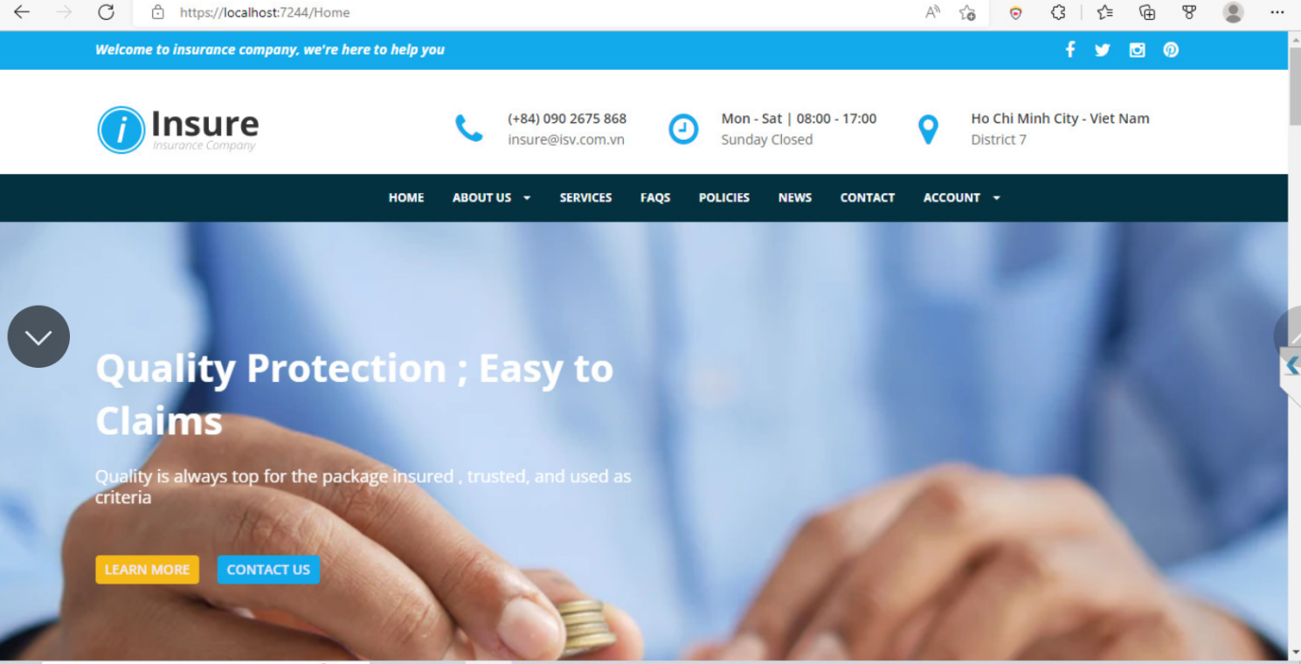

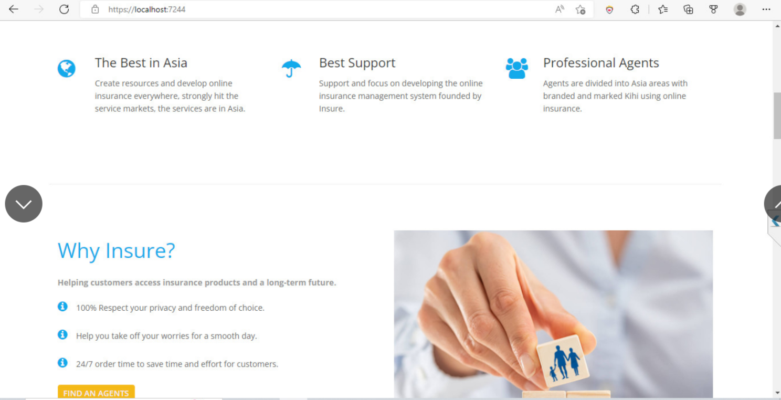

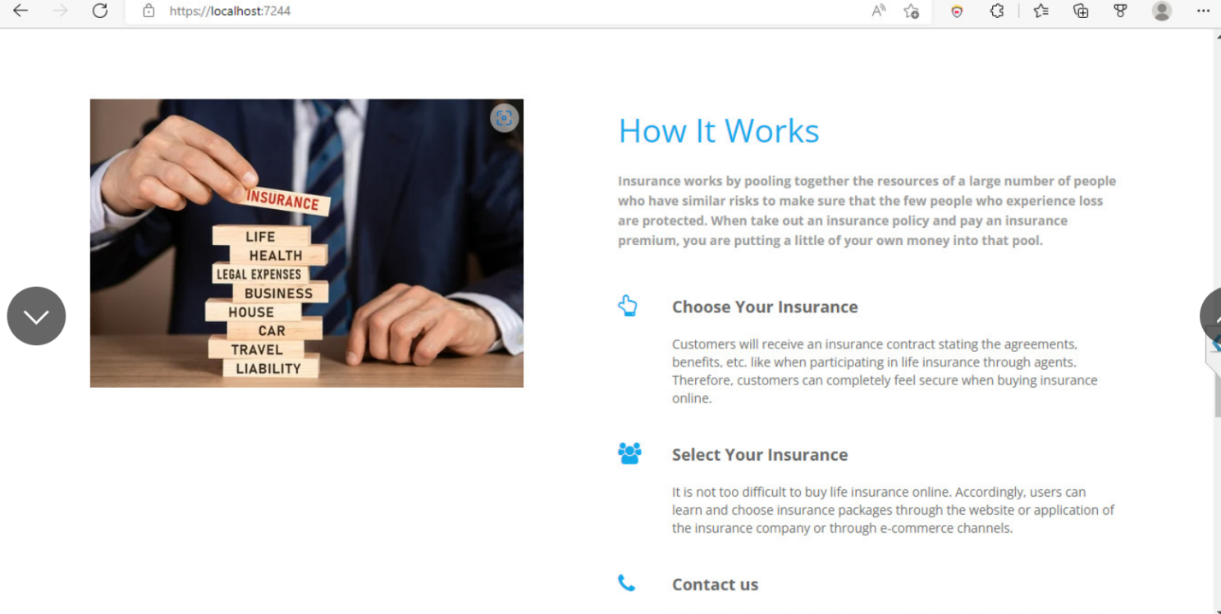

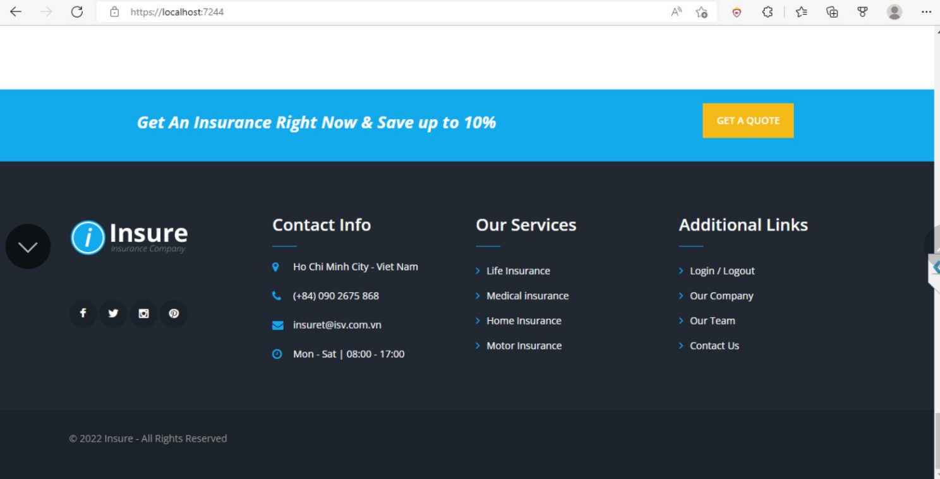

|  |  |  |  |  |  |  |
| --- | --- | --- | --- | --- | --- | --- |
| **No** | **Name** | **Type** | **Validation** | **Event** | **Description** | **Status** |
| 1 | Logo | Image |  | Click | Click to go to Homepage | Enable |
| 2 | Navigation bar | Hyperlink |  | Click | Click to go to Homepage | Enable |
| 3 | About Us | Hyperlink |  | Click | Click to go to About Us page | Enable |
| 4 | Service |  |  | Click | Click to go to Service | Enable |
| 5 | Home Slider | Slider |  | Surfing | Some information and quotes about Insurance | Enable |
| 6 | FAQ | Hyperlink |  | Click | Click to go to FAQs | Enable |
| 9 | Policies | Hyperlink |  | Click | Click to go to Policies | Enable |
| 10 | News | Hyperlink |  | Click | Click to go to News | Enable |
| 12 | Contact | Hyperlink |  | Click | Click to go to Contact page | Enable |
| 15 | Account | Button |  |  | Click to go to Login | Enable |

1. **Service page:**

**+** Information Insurance service

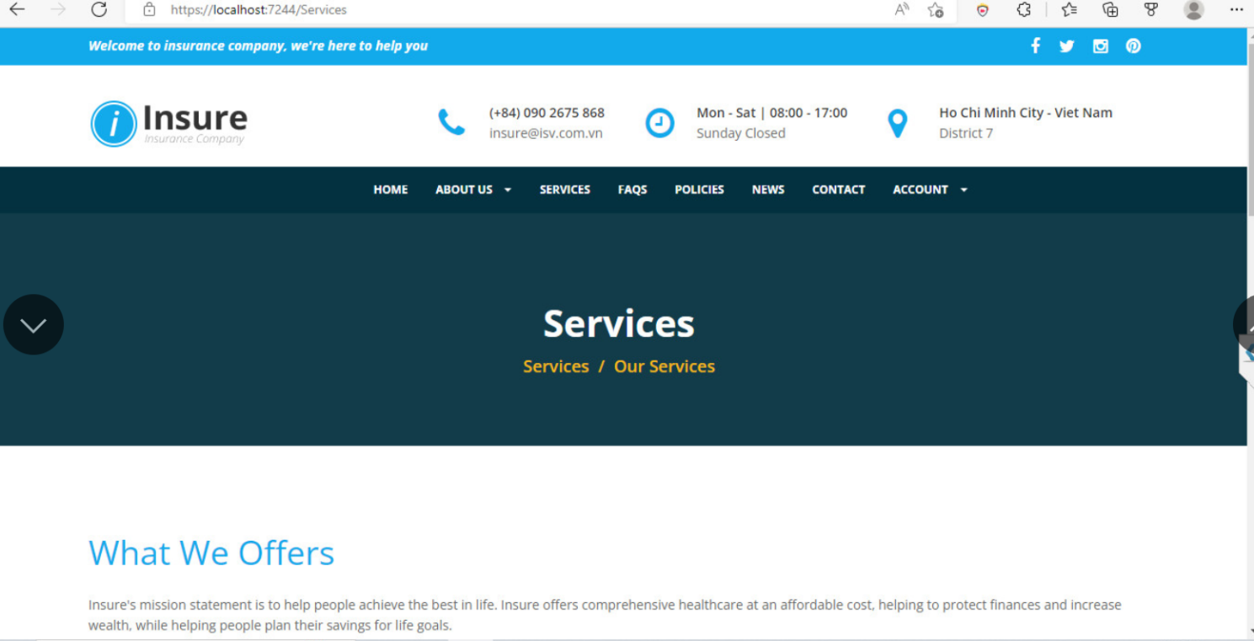

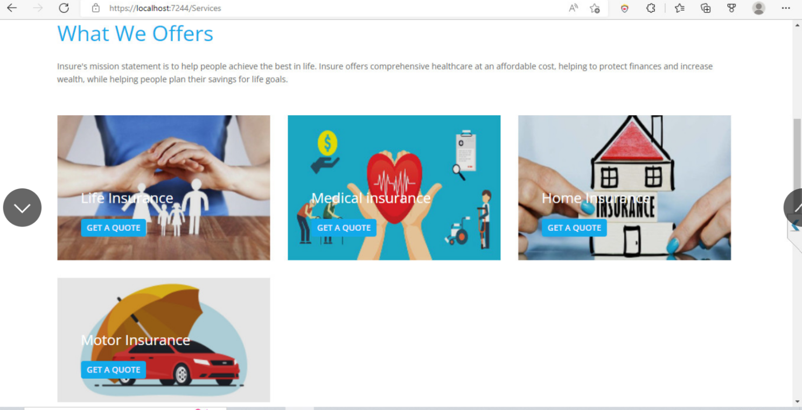

+Insurance Service details:

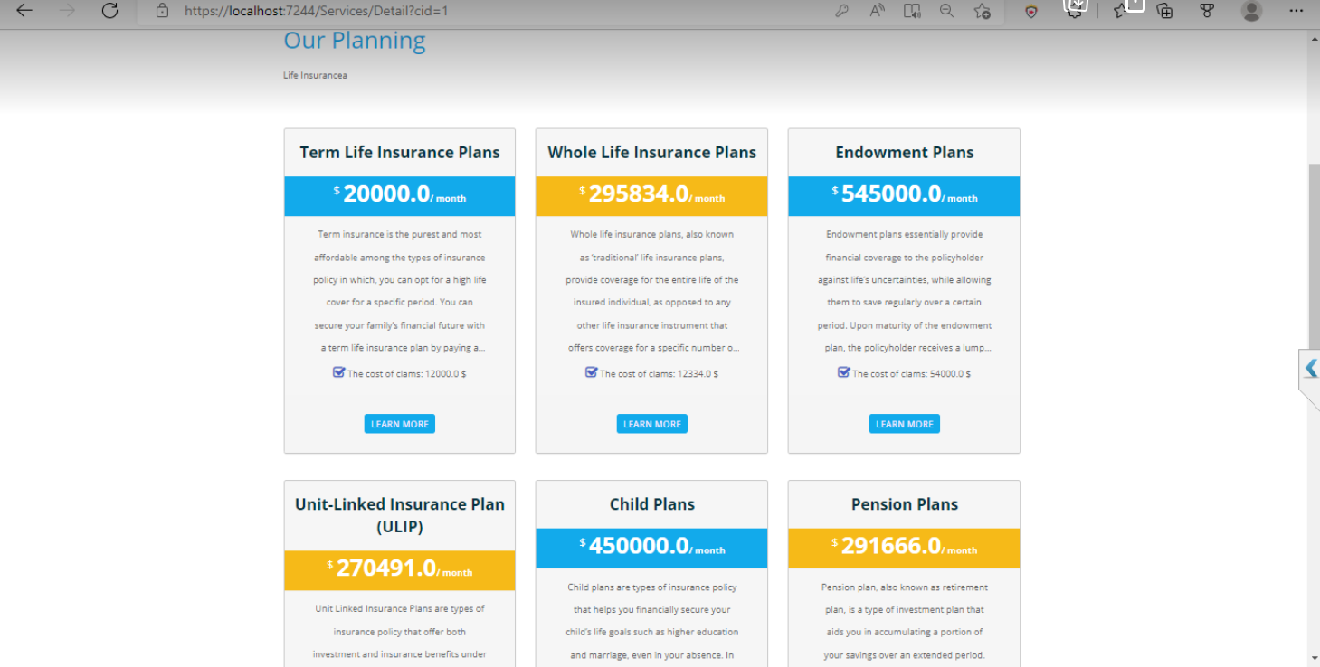

|  |  |  |  |  |  |  |
| --- | --- | --- | --- | --- | --- | --- |
| **No** | **Name** | **Type** | **Validation** | **Event** | **Description** | **Status** |
| 1 | Navigation bar | Hyperlink |  |  | Choose and click to go to pages | Enable |
| 2 | Service Insurance | button |  |  | Click to go to page details Insurance service | Enable |
| 3 | Services | Slider |  | Surfing | Information Service | Enable |

1. **+About Us page:** Some information about the Fine Arts Institute and student quotes.

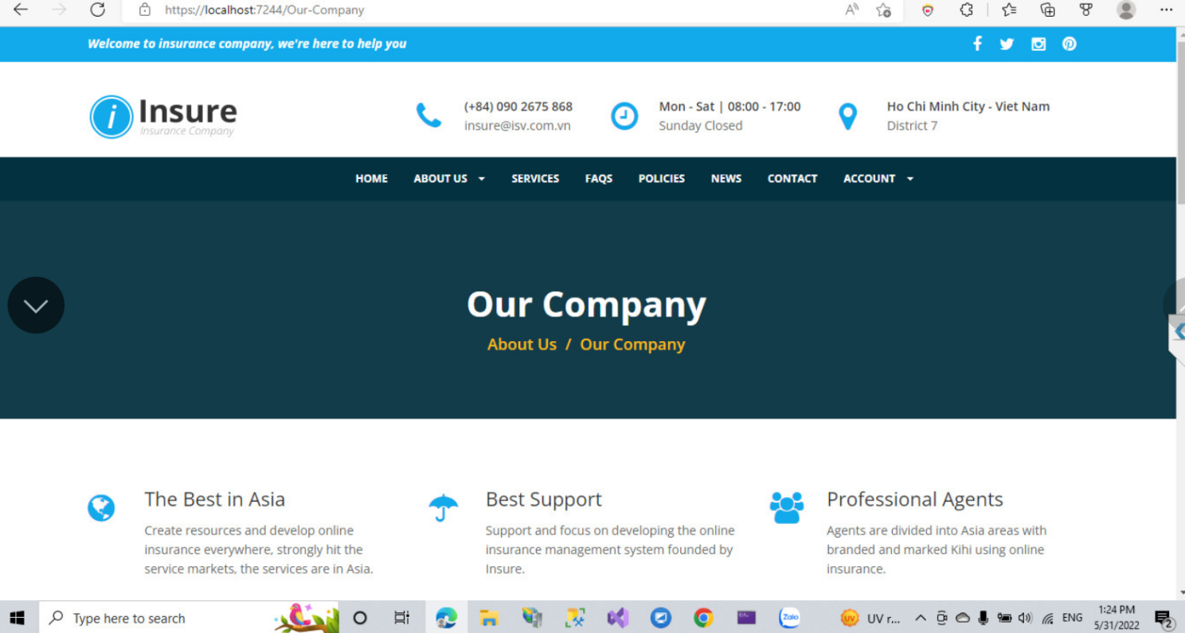

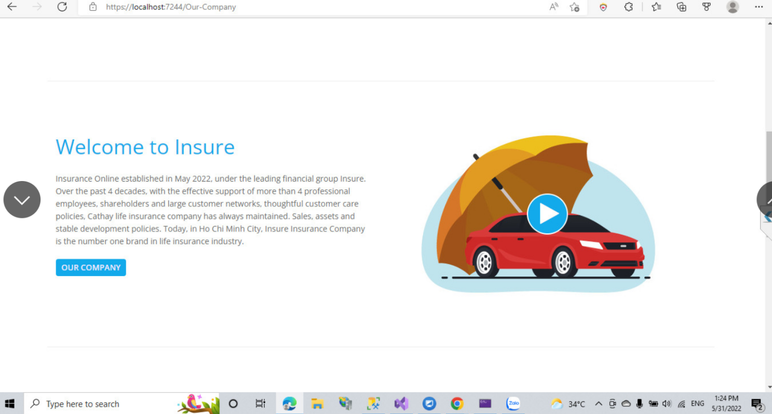

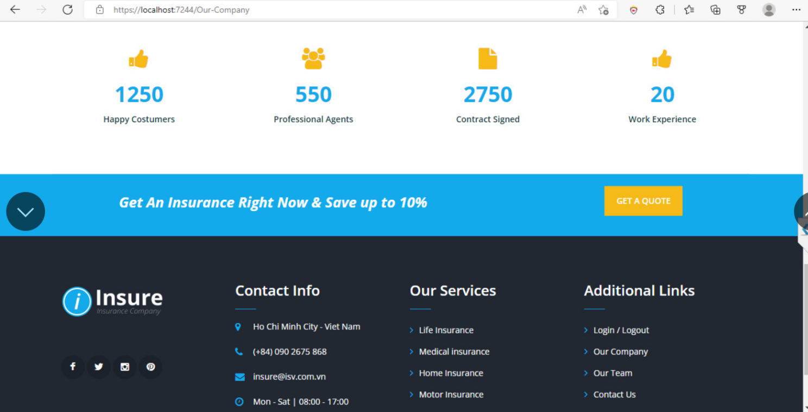

|  |  |  |  |  |  |  |
| --- | --- | --- | --- | --- | --- | --- |
| **No** | **Name** | **Type** | **Validation** | **Event** | **Description** | **Status** |
| 1 | Navigation bar | Hyperlink | Click | Click | Choose and click to go to pages | Enable |
| 2 | About Us Information | Text |  |  | Some information about Company | Enable |
| 3 | Our Company | Slider |  | Surfing | Information Company | Enable |

**+About Us page: Information Team**

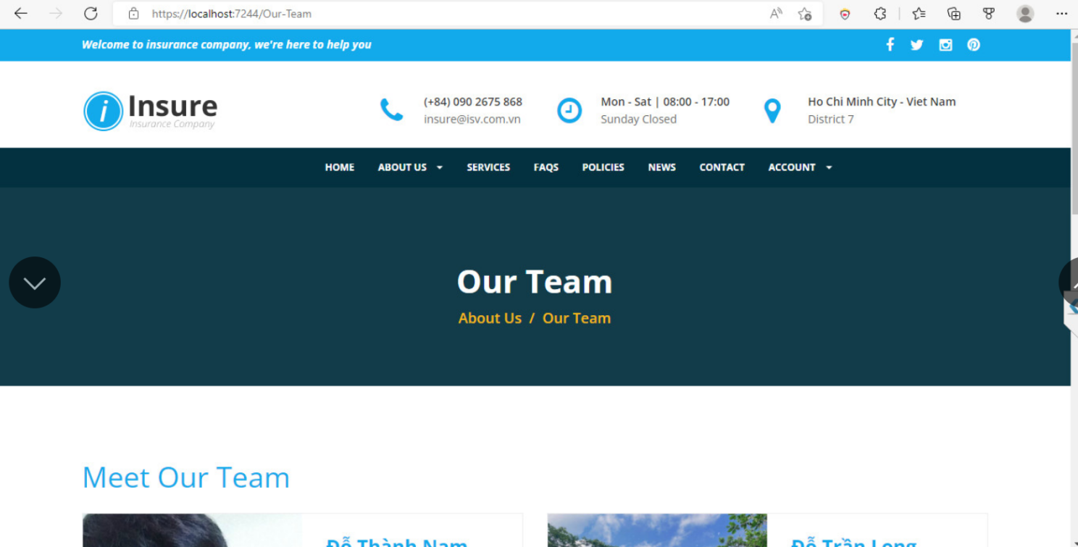

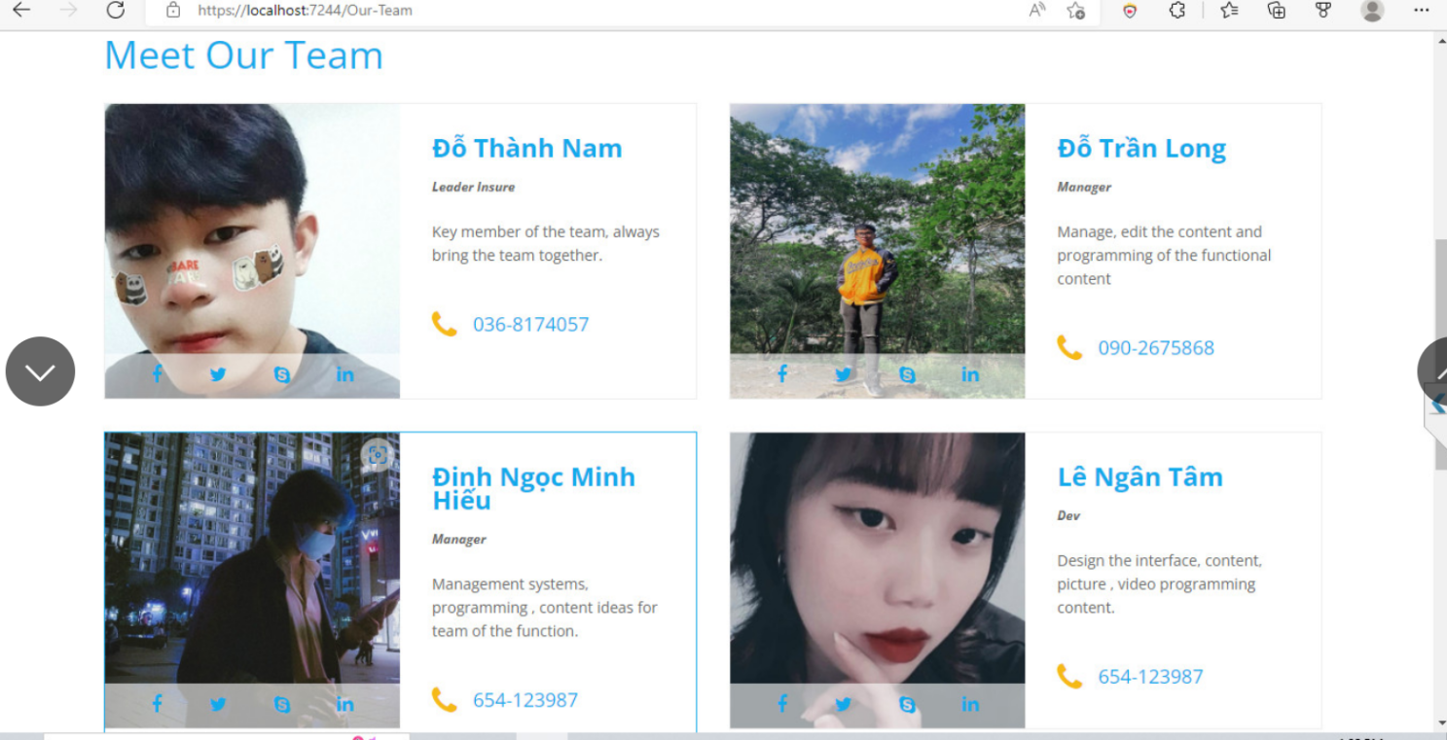

|  |  |  |  |  |  |  |
| --- | --- | --- | --- | --- | --- | --- |
| **No** | **Name** | **Type** | **Validation** | **Event** | **Description** | **Status** |
| 1 | Navigation Bar | Hyperlink |  | Click | Choose and click to go to pages | Enable |
| 2 | About us Team | Text |  | Text | Information our Team | Enable |
| 3 | Image | image |  |  | Image our team | Enable |

**1.4 FAQs: Information FAQs:**

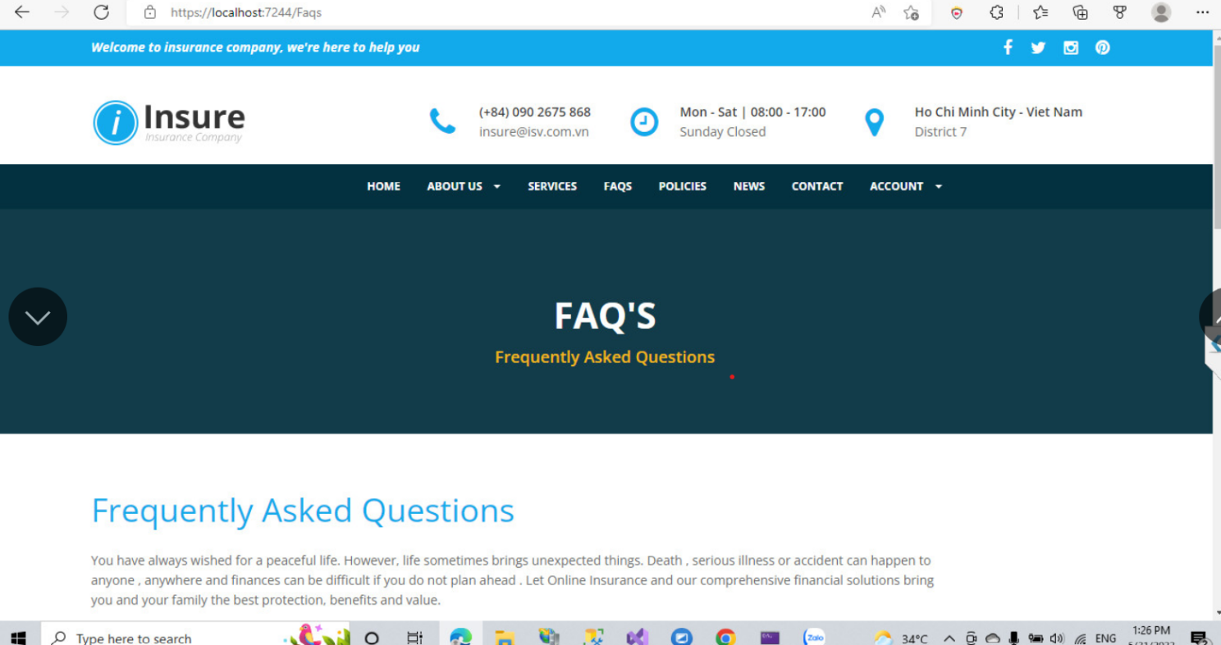

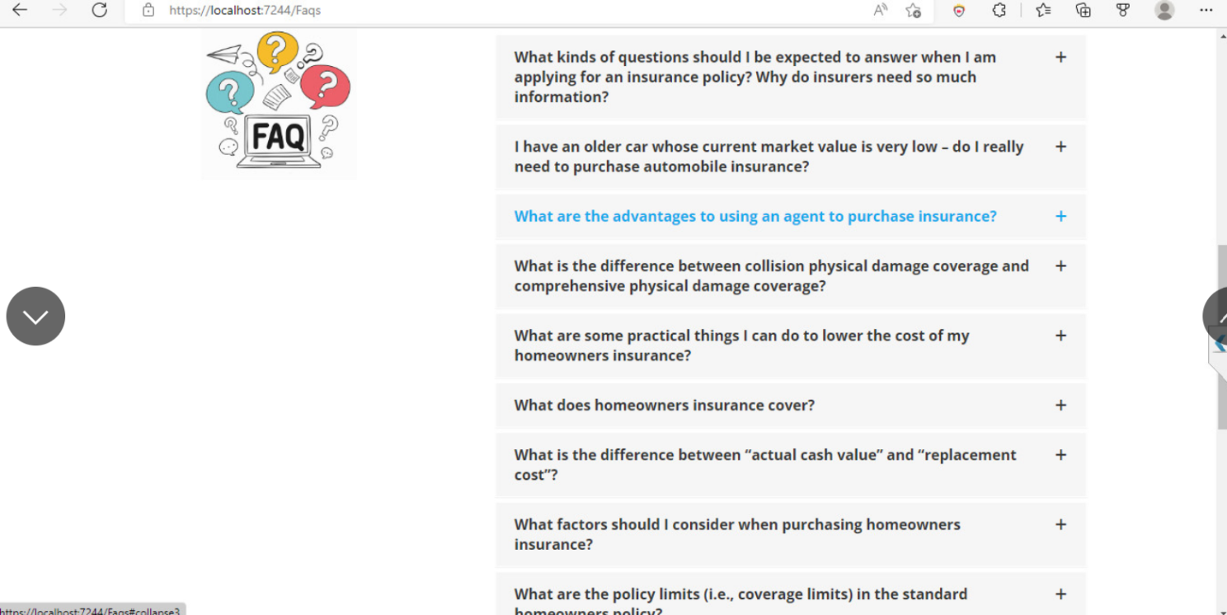

|  |  |  |  |  |  |  |
| --- | --- | --- | --- | --- | --- | --- |
| **No** | **Name** | **Type** | **Validation** | **Event** | **Description** | **Status** |
| 1 | Navigation Bar | Hyperlink |  | Click | Choose and click to go to pages | Enable |
| 2 | FAQs | Text |  | Text | Information FAQs Insurance service | Enable |

**1.5: Policies :Information Policies Insurance service**

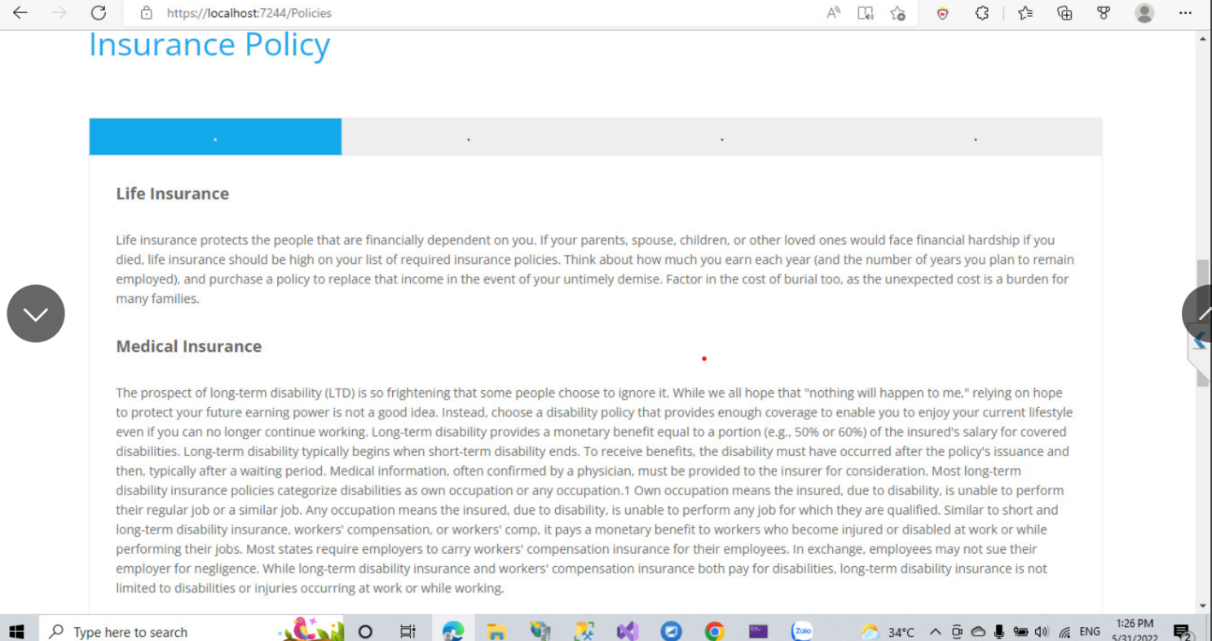

|  |  |  |  |  |  |  |
| --- | --- | --- | --- | --- | --- | --- |
| **No** | **Name** | **Type** | **Validation** | **Event** | **Description** | **Status** |
| 1 | Navigation Bar | Hyperlink |  | Click | Choose and click to go to pages | Enable |
| 2 | Policies | Text |  | Text | Information Policies Insurance service | Enable |

**1.6:News :Information News Insurance service**

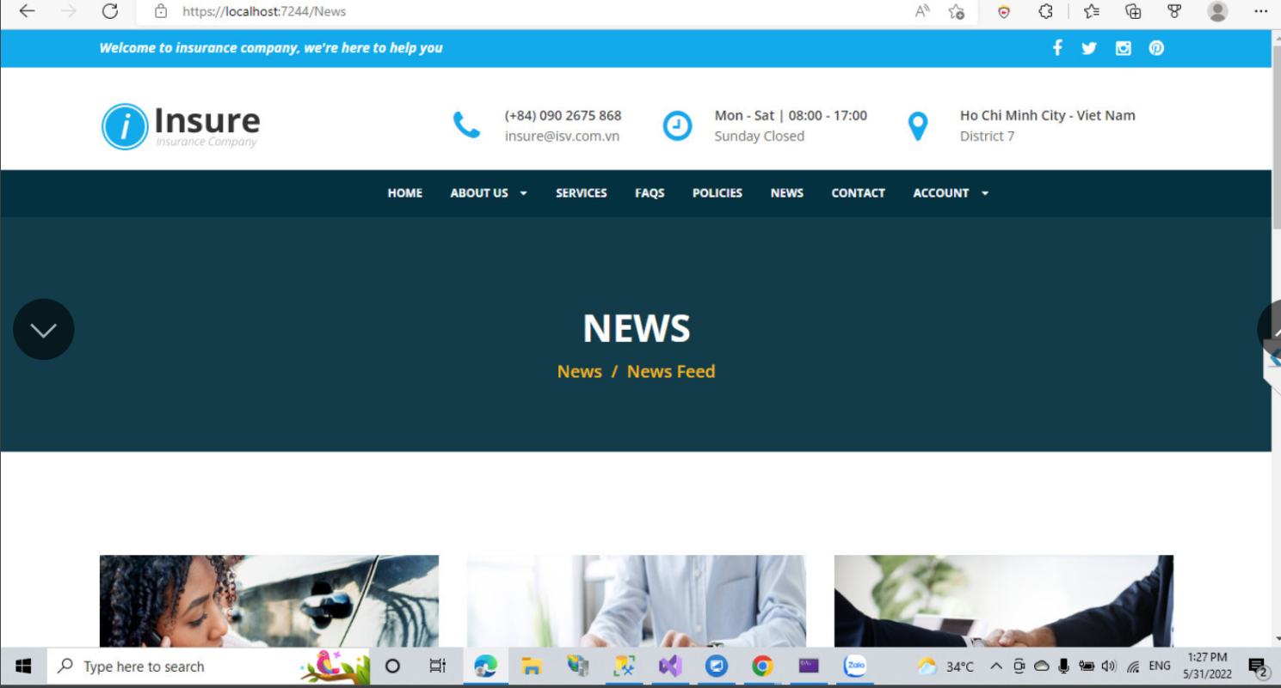

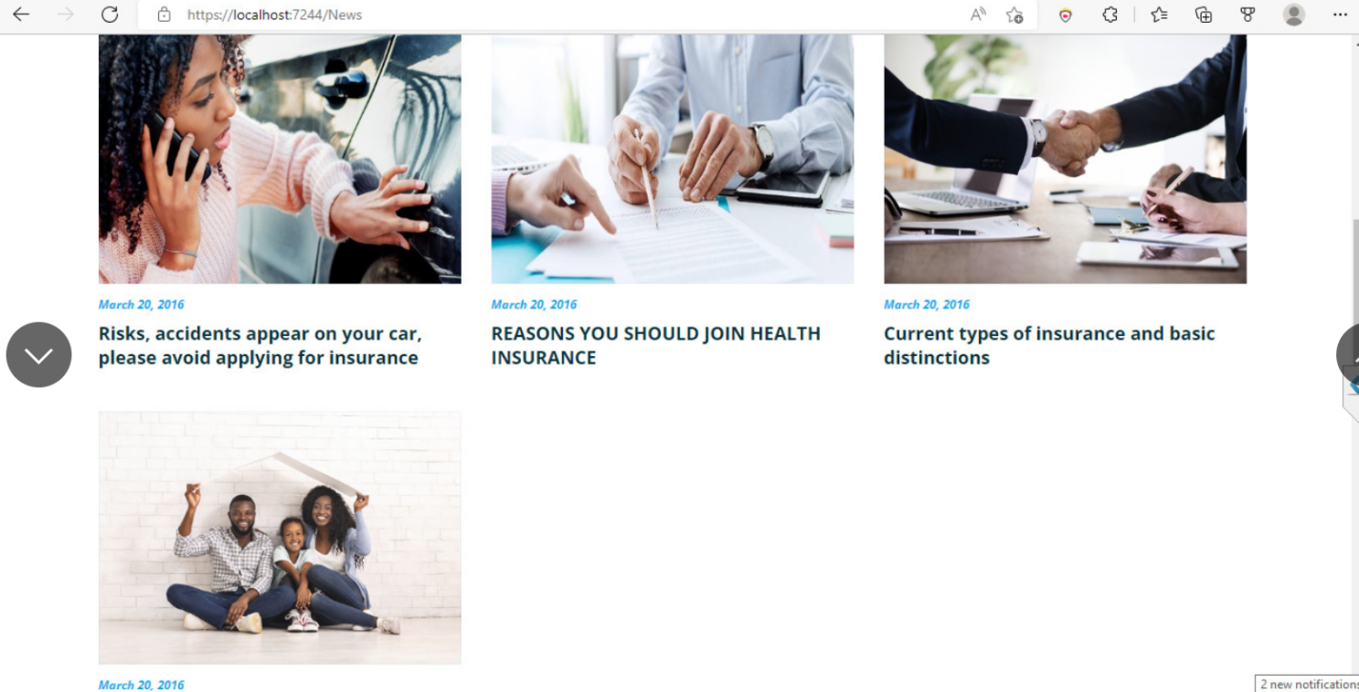

|  |  |  |  |  |  |  |
| --- | --- | --- | --- | --- | --- | --- |
| **No** | **Name** | **Type** | **Validation** | **Event** | **Description** | **Status** |
| 1 | Navigation Bar | Hyperlink |  | Click | Choose and click to go to pages | Enable |
| 2 | News | Text |  | Text | Information New Insurance service | Enable |

**1.7 Contact :Information Info**

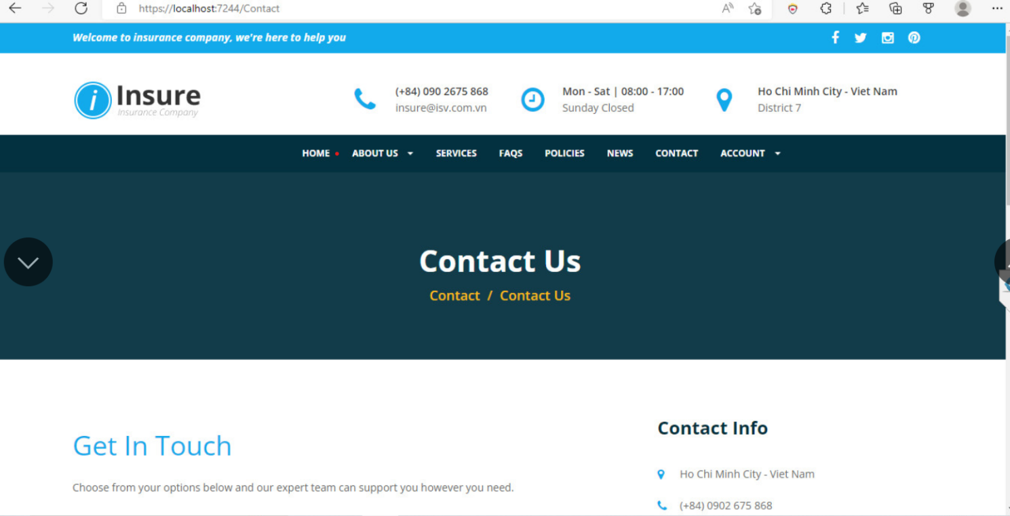

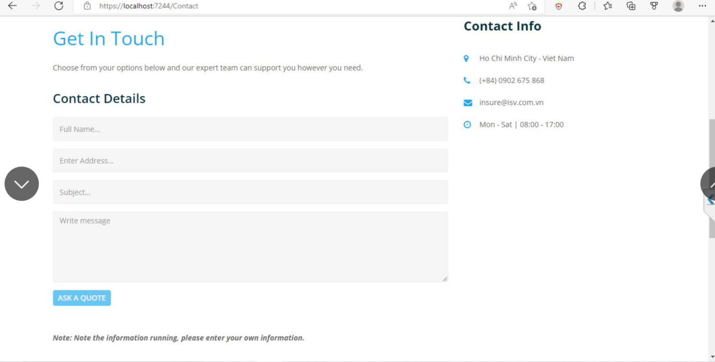

|  |  |  |  |  |  |  |
| --- | --- | --- | --- | --- | --- | --- |
| **No** | **Name** | **Type** | **Validation** | **Event** | **Description** | **Status** |
| 1 | Navigation Bar | Hyperlink |  |  | Choose and click to go to pages | Enable |
| 2 | Contact | Text |  |  | Information contact our company | Enable |

**1.8 Account/ Login:**

Here we can login with 3 types of accounts: admin,customers.

You can use some account below to test:admin,customer

+Customer account : theanh@gmail.com Password: 123

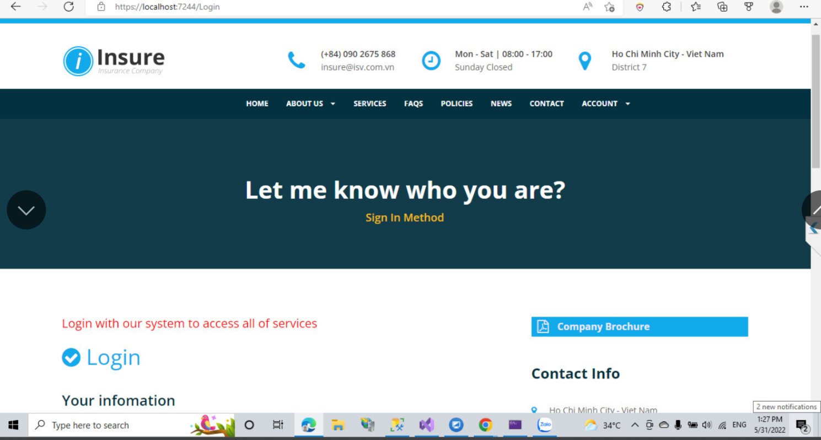

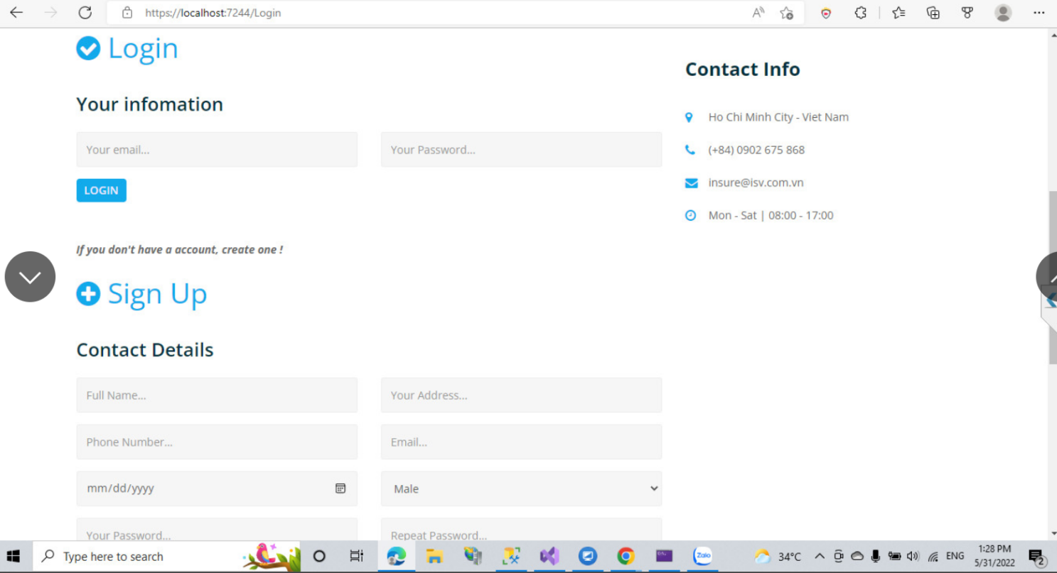

|  |  |  |  |  |  |  |
| --- | --- | --- | --- | --- | --- | --- |
| **No** | **Name** | **Type** | **Validation** | **Event** | **Description** | **Status** |
| 1 | FullName | Input | Required | Focus | Input FullName | Enable |
| 2 | Password | Input | Required | Focus | Input Password | Enable |
| 3 | Account/Login | Button |  | Click | Log in | Enable |

**1.9 Register:**

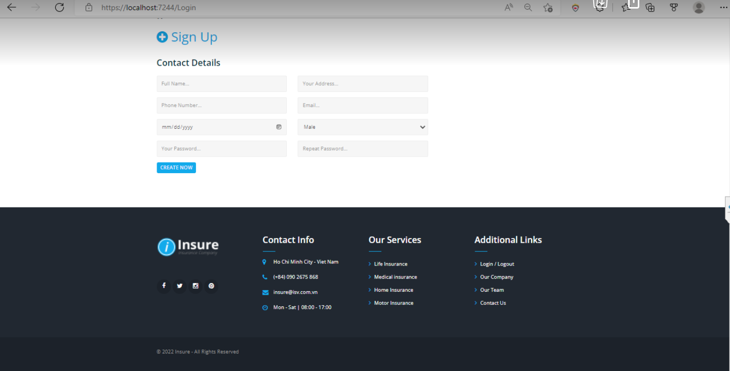

|  |  |  |  |  |  |  |
| --- | --- | --- | --- | --- | --- | --- |
| **No** | **Name** | **Type** | **Validation** | **Event** | **Description** | **Status** |
| 1 | FullName | Input | Required | Focus | Input FullName | Enable |
| 2 | Password | Input | Required | Focus | Input Password | Enable |
| 3 | Repeat Password | Input | Required | Focus | Input Repeat Password | Enable |
| 4 | Your Address | Input | Required |  | Input Address | Enable |
| 5 | Phone | Input | Required |  | Input Phone | Enable |
| 6 | Email | Input | Required |  | Input Email | Enable |
| 7 | Date | Textbox |  |  | Input Date | Enable |
| 8 | Create Now | Button |  | Click | Create now | Enable |

**1.10 Customer Login page:**

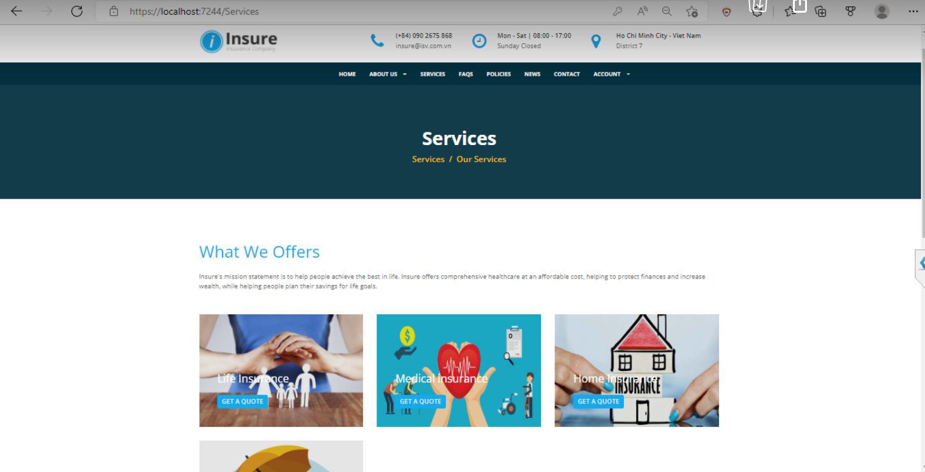

|  |  |  |  |  |  |  |
| --- | --- | --- | --- | --- | --- | --- |
| **No** | **Name** | **Type** | **Validation** | **Event** | **Description** | **Status** |
| 1 | Logout | Hyperlink |  | Click | Logout | Enable |

**1.11 Customer Login Service Page:**



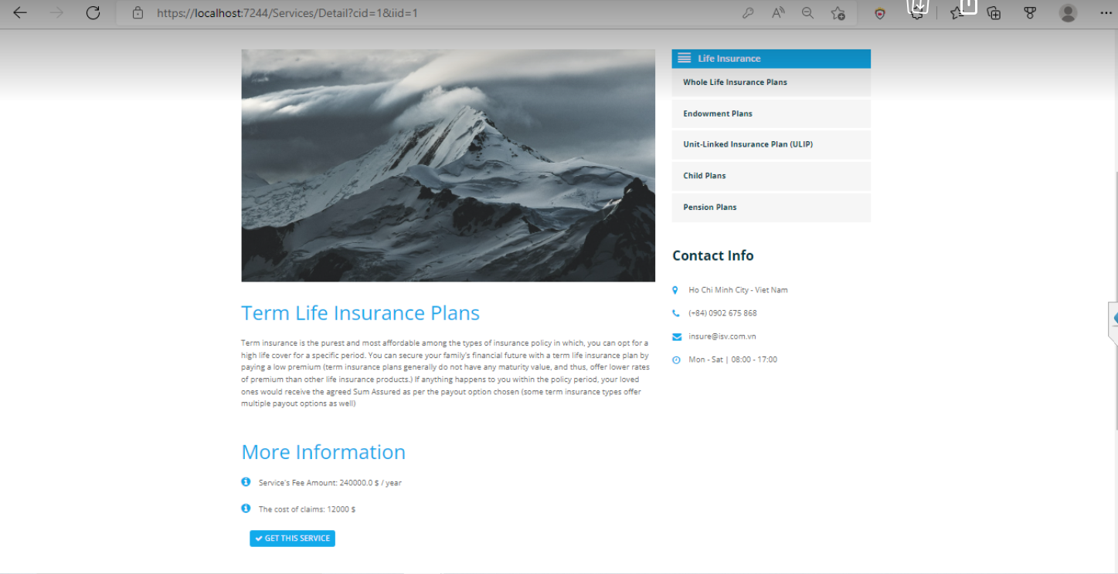

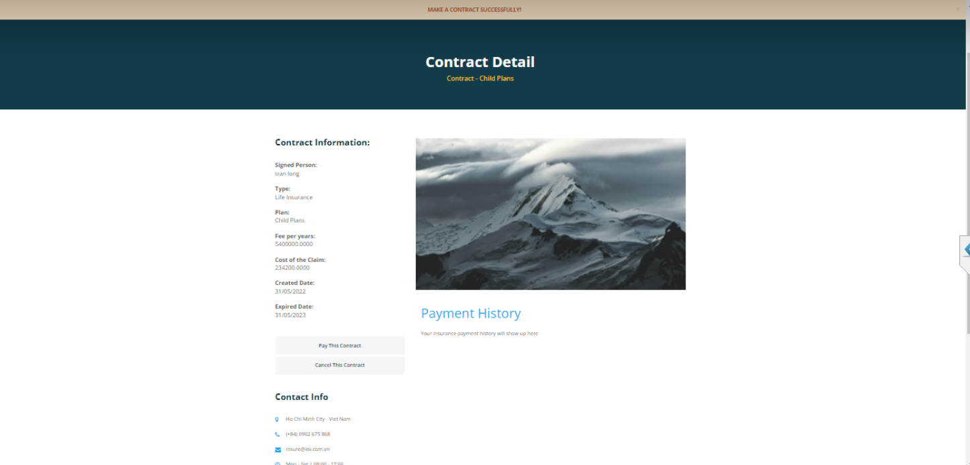

|  |  |  |  |  |  |  |
| --- | --- | --- | --- | --- | --- | --- |
| **No** | **Name** | **Type** | **Validation** | **Event** | **Description** | **Status** |
| 1 | Contract Detail | Div |  |  | Show Information contract | Enable |
| 2 | Image insurance | Div |  |  | Show image insurance | Enable |
| 3 | Fee per years | Div |  |  | Total Insurance | Enable |

**1.12 Customer Information:**

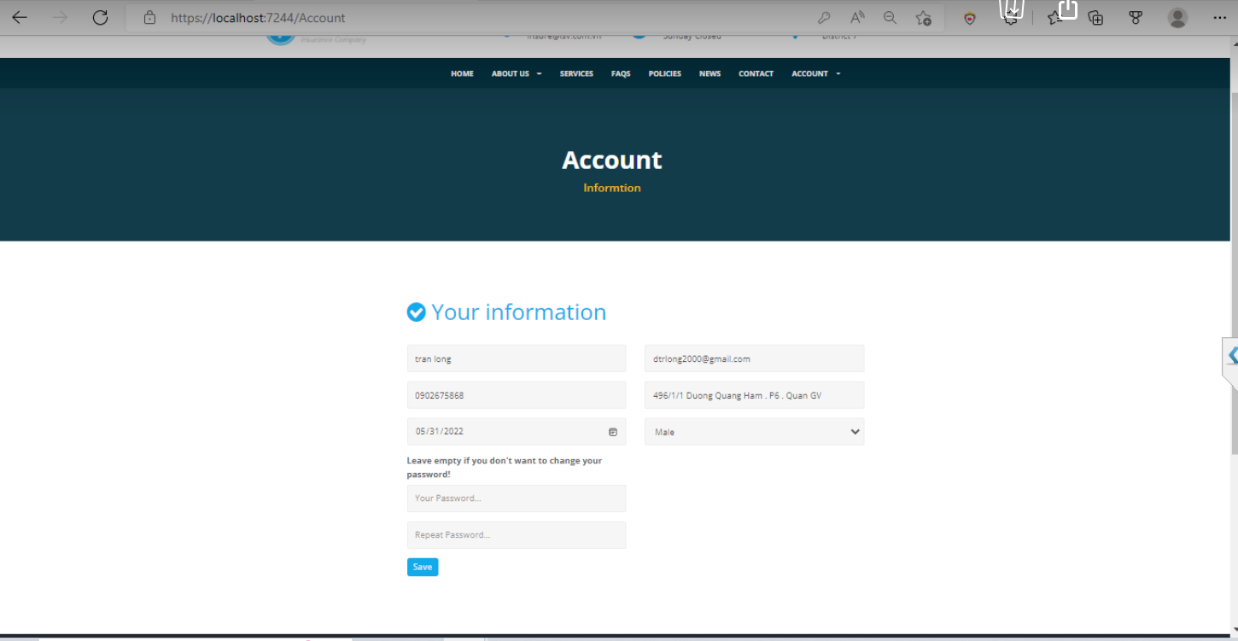

|  |  |  |  |  |  |  |
| --- | --- | --- | --- | --- | --- | --- |
| **No** | **Name** | **Type** | **Validation** | **Event** | **Description** | **Status** |
| 1 | FullName | Div |  |  | Information FullName | Enable |
| 2 | Phone | Div |  |  | Information Phone | Enable |
| 3 | Address | Div |  |  | Information address | Enable |
| 4 | Date | Div |  |  | Information Date | Enable |
| 5 | Male | Div |  |  | Information Male | Enable |
| 6 | Your password | Form |  |  | Enter a password |  |
| 6 | Repeat password | Form |  |  | Update password customer | Enable |

**2.Admin Page**

**2.1 Login admin :**

After logging in with a admin account, we will have the account interface as below:

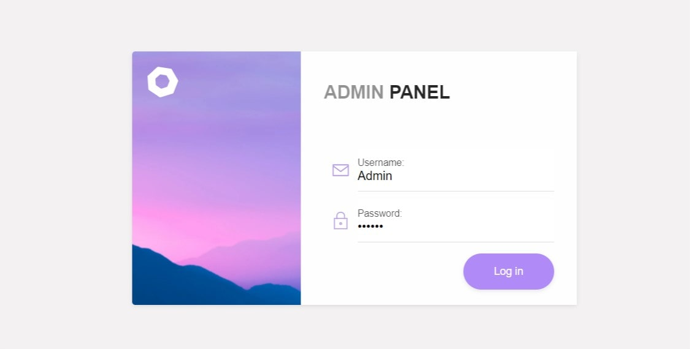

You can use some account below to test:admin

+Admin account : admin Password : admin

|  |  |  |  |  |  |  |
| --- | --- | --- | --- | --- | --- | --- |
| **No** | **Name** | **Type** | **Validation** | **Event** | **Description** | **Status** |
| 1 | Username | Input | Required | Focus | Input Username | Enable |
| 2 | Password | Input | Required | Focus | Input Password | Enable |
| 3 | Login | Button |  | Click | Click go to Admin page | Enable |

**2.2 Home page Admin:**

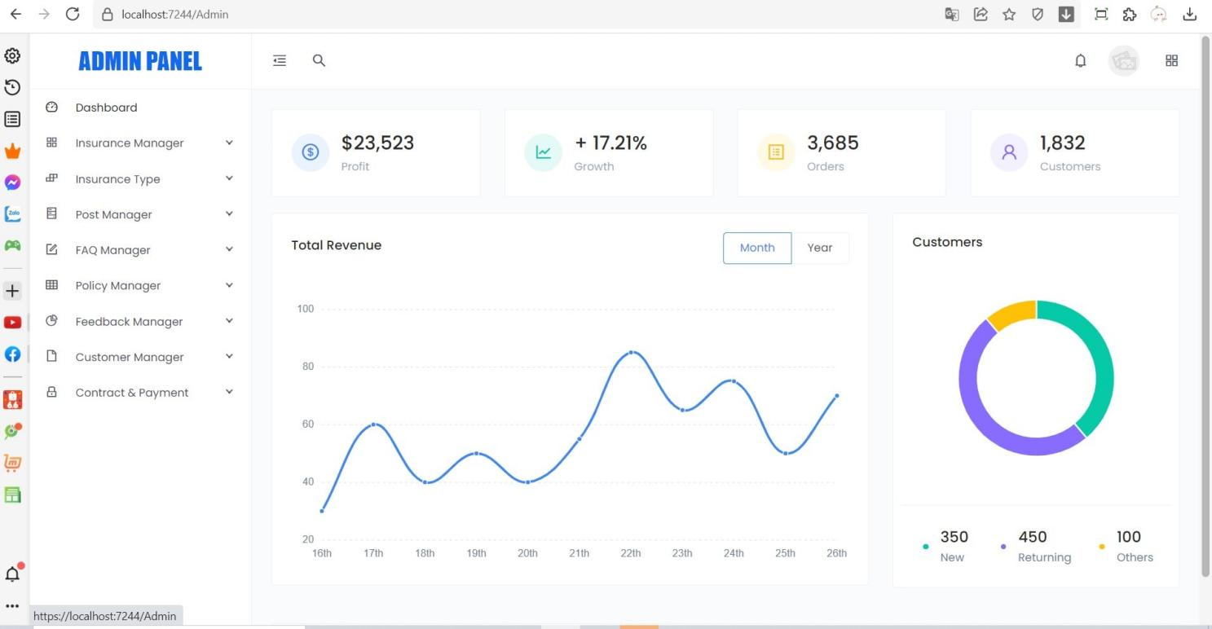

|  |  |  |  |  |  |  |
| --- | --- | --- | --- | --- | --- | --- |
| **No** | **Name** | **Type** | **Validation** | **Event** | **Description** | **Status** |
| 1 | Manager Insurance | Hyperlink |  | Click | Click to go to Insurance List page | Enable |
| 2 | Insurance Type | Hyperlink |  | Click | Click to go to Insurance Type | Enable |
| 3 | Post Manager | Hyperlink |  | Click | Click to go to Post Manager page | Enable |
| 4 | FAQs Manager | Hyperlink |  | Click | Click to go to FAQs page | Enable |
| 5 | Policy Manager | Hyperlink |  | Click | Click to go to Policy Page | Enable |
| 6 | Feedback | Hyperlink |  | Click | Click to go to feedback page | Enable |
| 7 | Customer Manager | Hyperlink |  | Click | Click to go to Customer page | Enable |
| 8 | Contract & payment | Hyperlink |  | Click | Click to go to Contact & payment |  |
| 9 | Logout | Button |  | Click | Click to logout | Enable |
| 10 | Dashboard | Hyperlink |  | Click | Click to go to home page admin | Enable |

**2.3 Manager Insurance:**

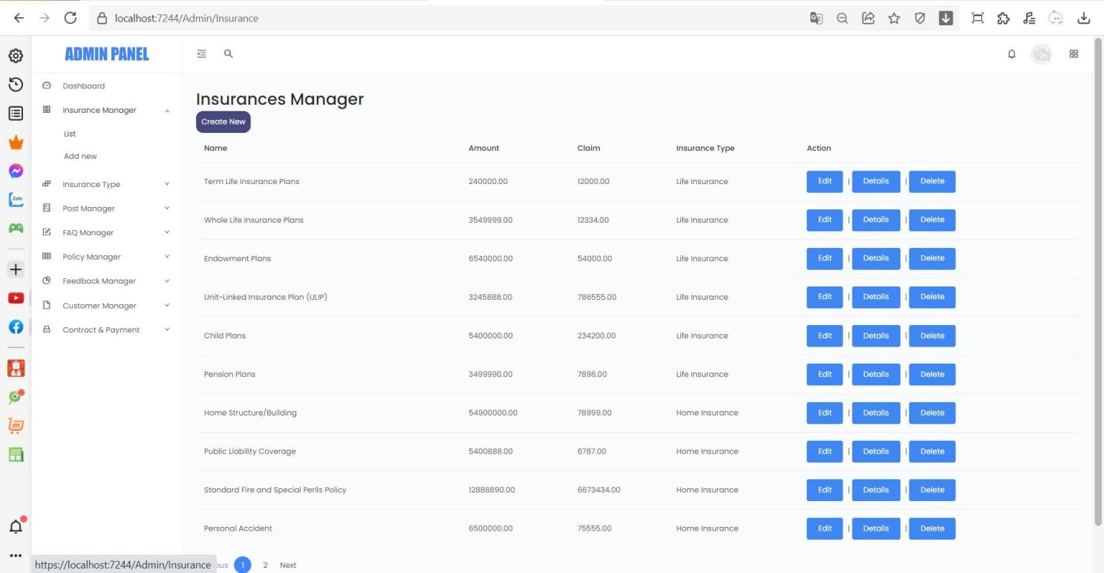

|  |  |  |  |  |  |  |
| --- | --- | --- | --- | --- | --- | --- |
| **No** | **Name** | **Type** | **Validation** | **Event** | **Description** | **Status** |
| 1 | Add New | Button |  | Click | Click to go to add new Insurance manager | Enable |
| 2 | Update | Button |  | Click | Click to go to add update Insurance manager | Enable |
| 3 | Delete | Button |  | Click | Click to go to add delete Insurance manager | Enable |
| 4 | Details | Button |  | Click | Click to go to add Details Insurance manager | Enable |

**2.4 Add new Insurance manager:**

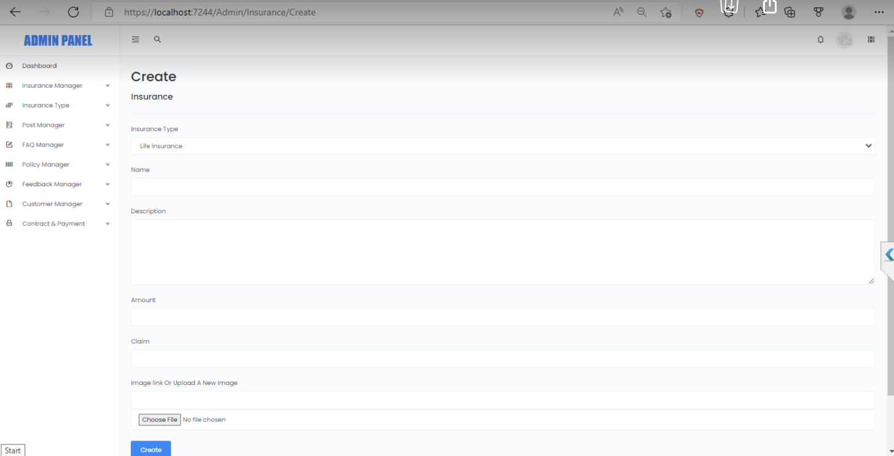

|  |  |  |  |  |  |  |
| --- | --- | --- | --- | --- | --- | --- |
| **No** | **Name** | **Type** | **Validation** | **Event** | **Description** | **Status** |
| 1 | Insurance Type | Select | -Not null | Click | Input: Insurance Type | Enable |
| 2 | Name | Text Box | -Not null | Click | Input: Name | Enable |
| 3 | Description | Text Box | -Not null | Click | Input: Description | Enable |
| 4 | Amount | Text Box | -Not null | Click | Input: Amount | Enable |
| 5 | Claim | Text Box | -Not null | Click | Input:Claim | Enable |
| 6 | Image link | Text Box | -Not null | Select | Input: Image | Enable |
| 7 | Image | Button | -Not null | Click | Input: Image | Enable |
| 8 | Create | Hyperlink |  | Click | Click to submit create Insurance | Enable |

**2.5 Update insurance manager:**

**2.6 Insurance type:**

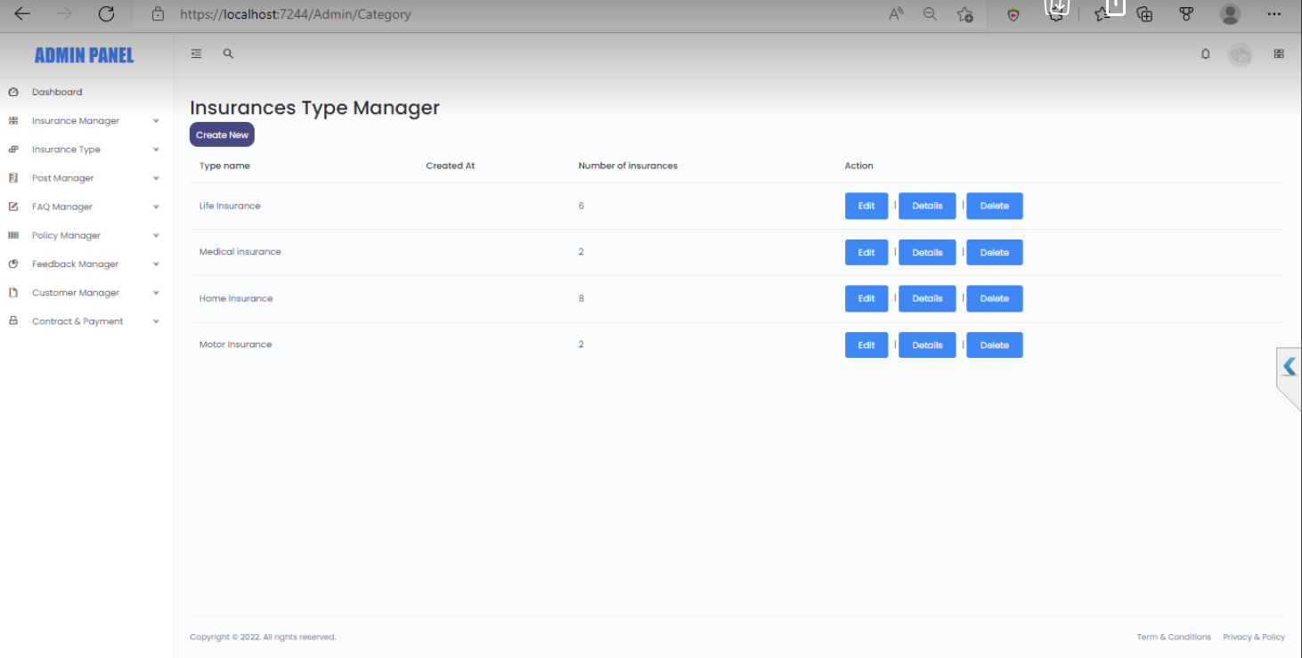

|  |  |  |  |  |  |  |
| --- | --- | --- | --- | --- | --- | --- |
| **No** | **Name** | **Type** | **Validation** | **Event** | **Description** | **Status** |
| 1 | Create | Hyperlink |  | Click | Create to Category | Enable |
| 2 | Edit | Button |  | Click | Edit to Category | Enable |
| 3 | Details | Button |  | Click | Show detail Category | Enable |
| 4 | Delete | Button |  | Click | Delete Category | Enable |

**2.7 Add new insurance type:**

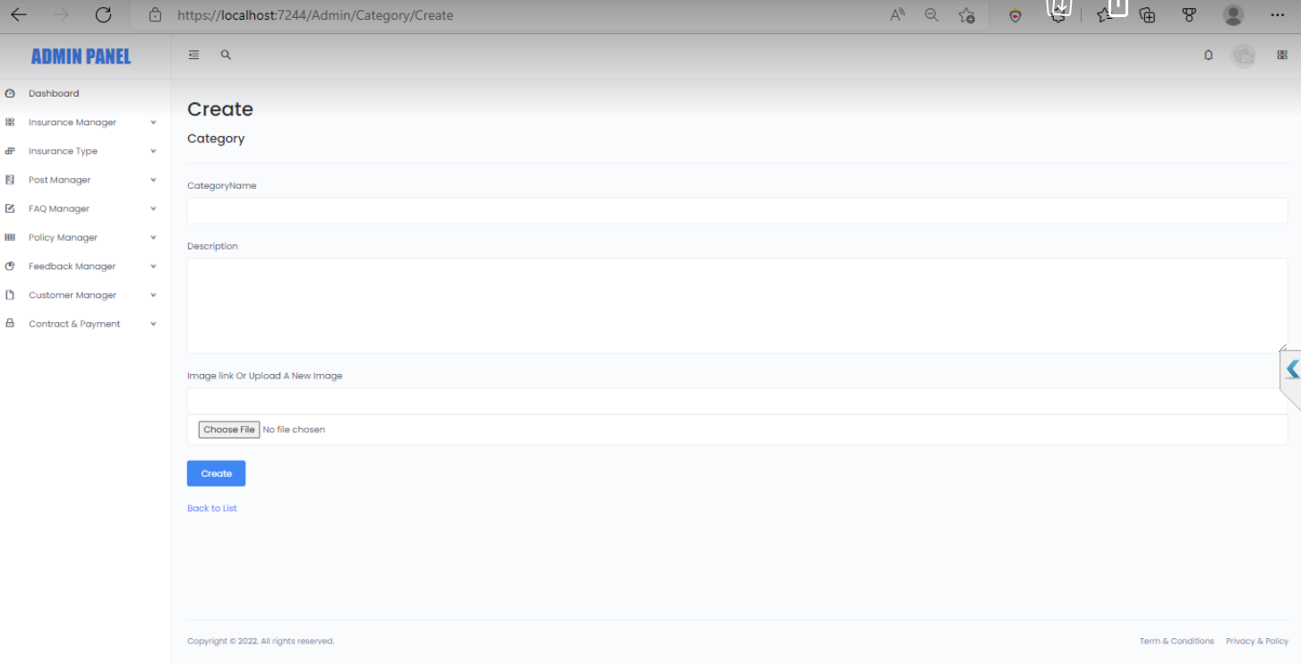

|  |  |  |  |  |  |  |
| --- | --- | --- | --- | --- | --- | --- |
| **No** | **Name** | **Type** | **Validation** | **Event** | **Description** | **Status** |
| 1 | Category  Name | Text Box | -Not null | Click | Input: Category Name | Enable |
| 2 | Description | Text Box | -Not null | Click | Input: Description | Enable |
| 3 | Image link | Text Box | -Not null | Select | Input: Image | Enable |
| 4 | Image | Button | -Not null | Click | Input: Image | Enable |
| 5 | Create | Hyperlink |  | Click | Click to submit create Category | Enable |

**2.8 Update insurance type:**

**2.9 Post manager:**

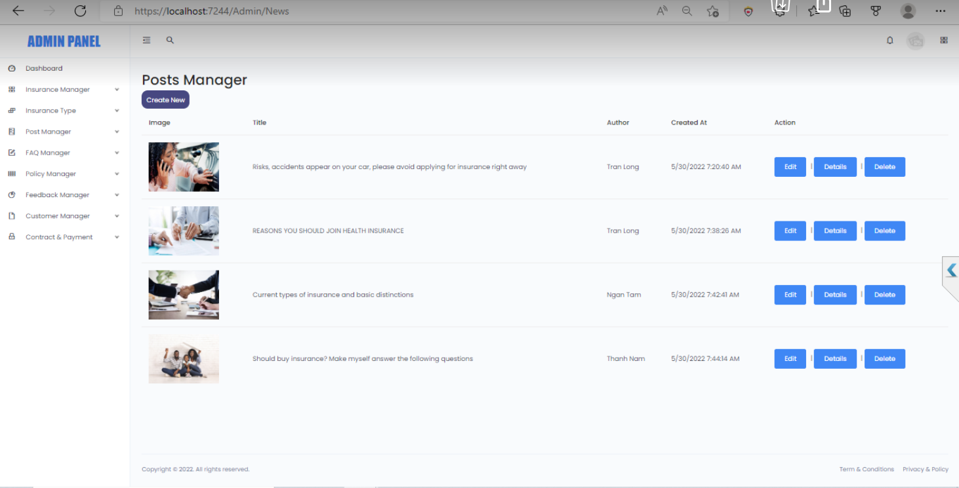

|  |  |  |  |  |  |  |
| --- | --- | --- | --- | --- | --- | --- |
| **No** | **Name** | **Type** | **Validation** | **Event** | **Description** | **Status** |
| 1 | Create | Hyperlink |  | Click | Create to News | Enable |
| 2 | Edit | Button |  | Click | Edit to News | Enable |
| 3 | Details | Button |  | Click | Show detail News | Enable |
| 4 | Delete | Button |  | Click | Delete News | Enable |

**2.10 Add new post manager:**

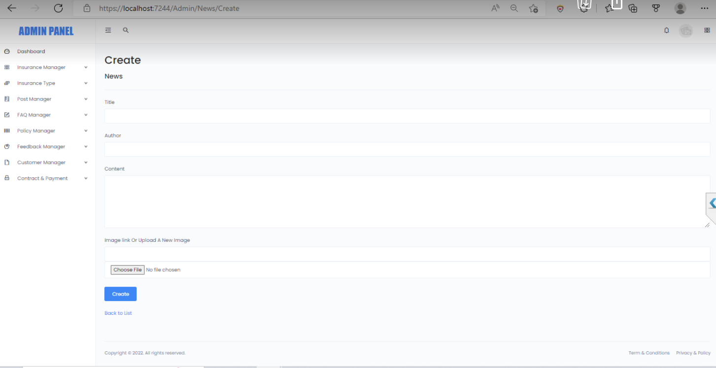

|  |  |  |  |  |  |  |
| --- | --- | --- | --- | --- | --- | --- |
| **No** | **Name** | **Type** | **Validation** | **Event** | **Description** | **Status** |
| 1 | Title | Text Box | -Not null | Click | Input: Title New | Enable |
| 2 | Author | Text Box | -Not null | Click | Input: Author | Enable |
| 3 | Content | Text Box | -Not null | Click | Input: Content New | Enable |
| 4 | Image link | Text Box | -Not null | Select | Input: Image | Enable |
| 5 | Image | Button | -Not null | Click | Input: Image | Enable |
| 6 | Create | Hyperlink |  | Click | Click to submit create News | Enable |

**2.11 Update post manager:**

**2.12 FAQ manager:**

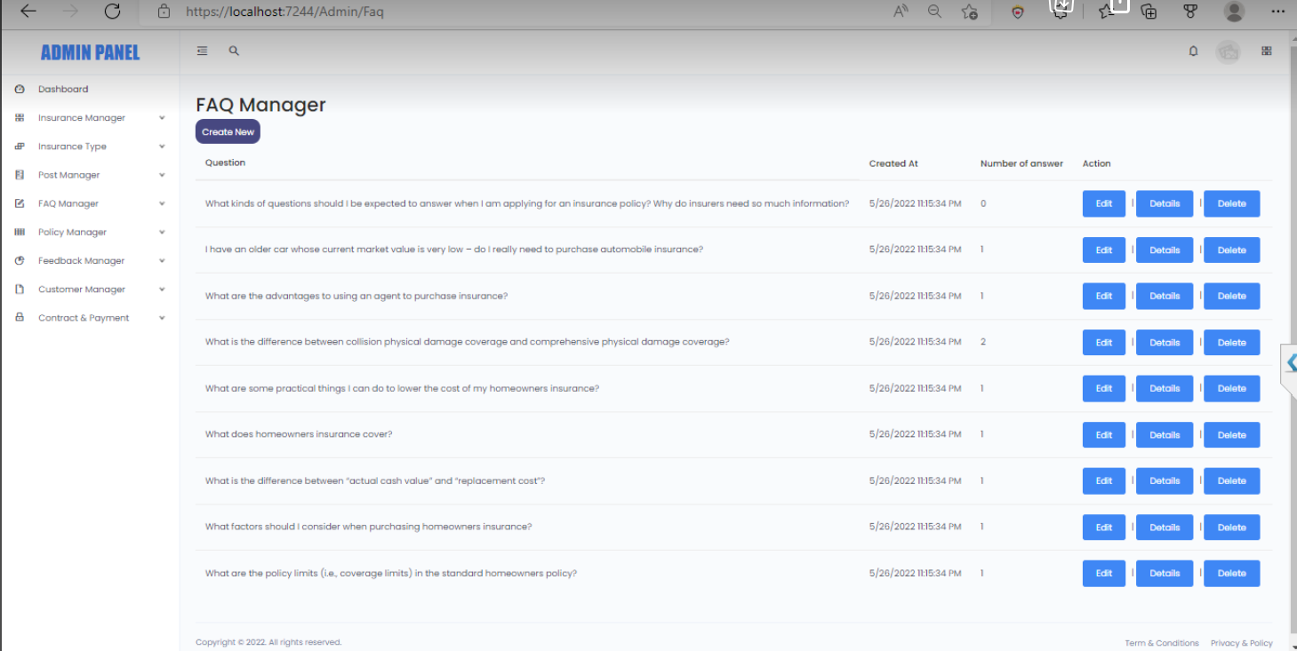

|  |  |  |  |  |  |  |
| --- | --- | --- | --- | --- | --- | --- |
| **No** | **Name** | **Type** | **Validation** | **Event** | **Description** | **Status** |
| 1 | Create | Hyperlink |  | Click | Create to Faq | Enable |
| 2 | Edit | Button |  | Click | Edit to Faq | Enable |
| 3 | Details | Button |  | Click | Show detail Faq | Enable |
| 4 | Delete | Button |  | Click | Delete Faq | Enable |

**2.13** **Add FAQs manager:**

**2.14 Update FAQs manager:**

**2.15 FAQs Reply Manager:**

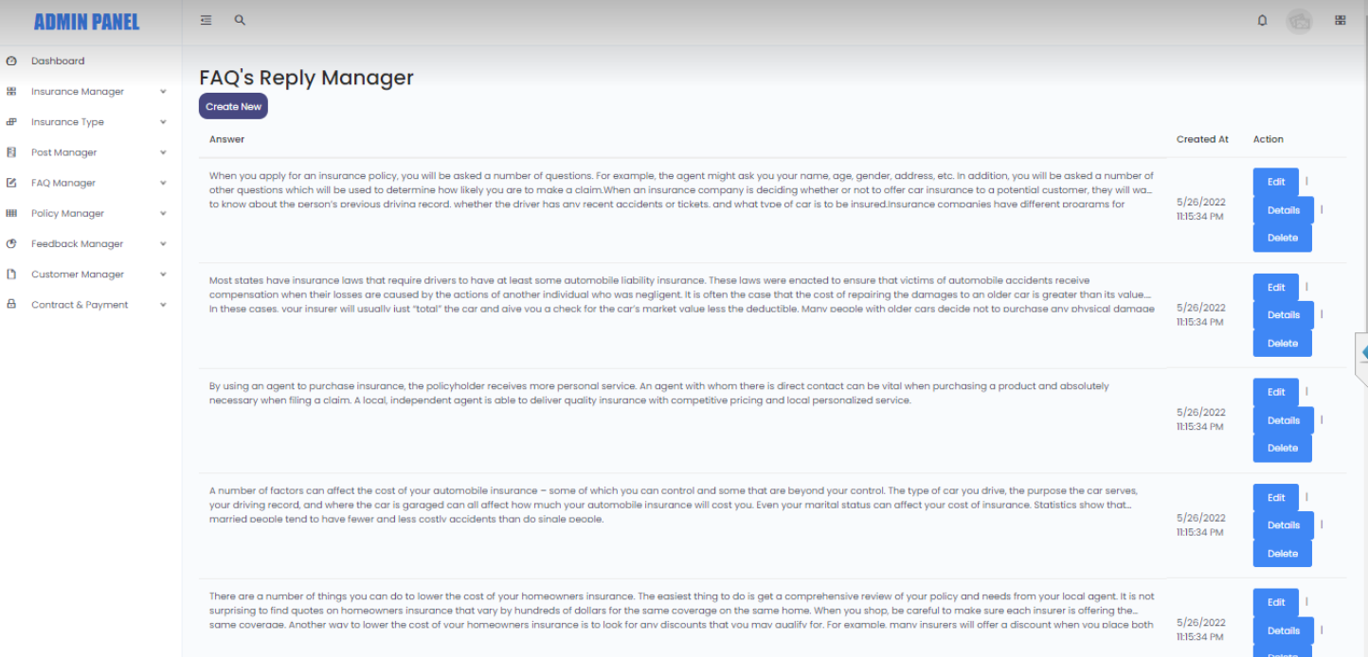

|  |  |  |  |  |  |  |
| --- | --- | --- | --- | --- | --- | --- |
| **No** | **Name** | **Type** | **Validation** | **Event** | **Description** | **Status** |
| 1 | Create | Hyperlink |  | Click | Create to News | Enable |
| 2 | Edit | Button |  | Click | Edit to News | Enable |
| 3 | Details | Button |  | Click | Show detail News | Enable |
| 4 | Delete | Button |  | Click | Delete News | Enable |

**2.16 Add FAQs Reply Manager:**

**2.17 Update FAQs Reply Manager:**

**2.18 Policy manager:**

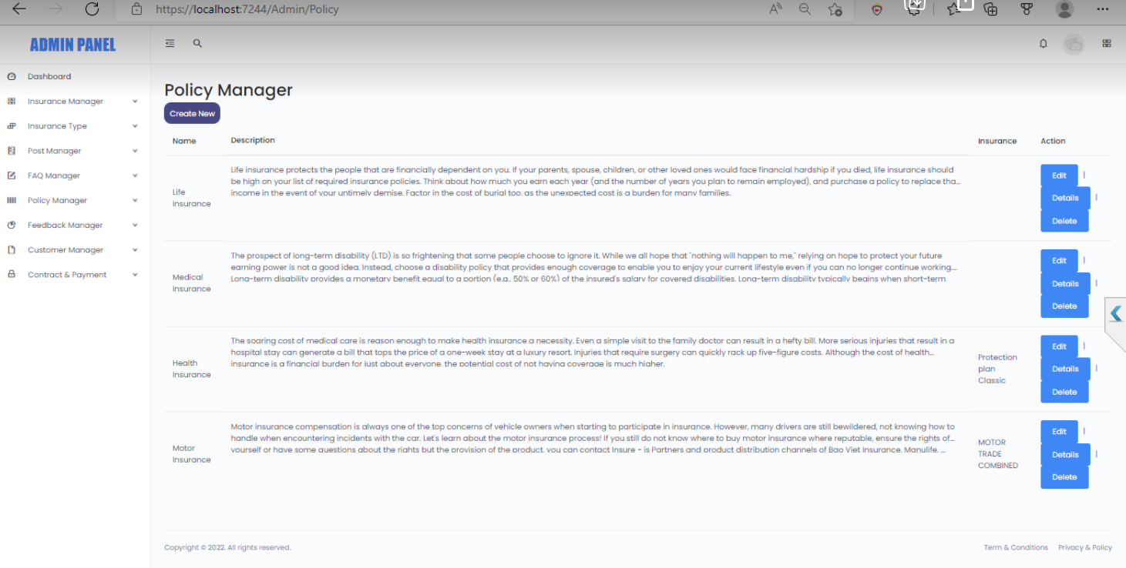

|  |  |  |  |  |  |  |
| --- | --- | --- | --- | --- | --- | --- |
| **No** | **Name** | **Type** | **Validation** | **Event** | **Description** | **Status** |
| 1 | Create | Hyperlink |  | Click | Create to Policy | Enable |
| 2 | Edit | Button |  | Click | Edit to Policy | Enable |
| 3 | Details | Button |  | Click | Show detail Policy | Enable |
| 4 | Delete | Button |  | Click | Delete Policy | Enable |

**2.19 Add new policy manager:**

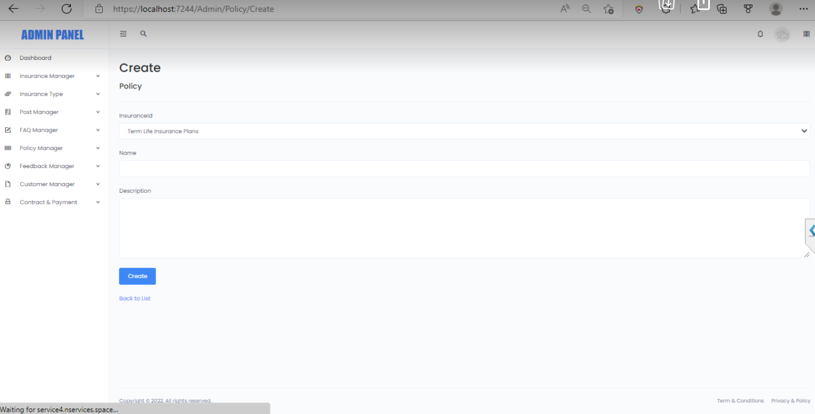

|  |  |  |  |  |  |  |
| --- | --- | --- | --- | --- | --- | --- |
| **No** | **Name** | **Type** | **Validation** | **Event** | **Description** | **Status** |
| 1 | Insurance ID | Select | -Not null | Click | Input: Insurance ID | Enable |
| 2 | Name | Text Box | -Not null | Click | Input: Name | Enable |
| 3 | Description | Text Box | -Not null | Click | Input: Description | Enable |
| 4 | Create | Hyperlink |  | Click | Click to submit create Policy | Enable |

**2.20 Update policy manager:**

**2.21 Feedback manager**

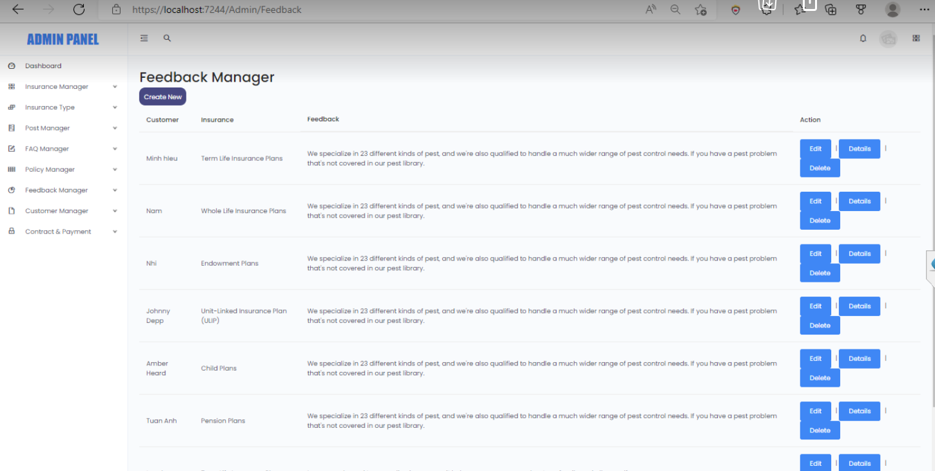

|  |  |  |  |  |  |  |
| --- | --- | --- | --- | --- | --- | --- |
| **No** | **Name** | **Type** | **Validation** | **Event** | **Description** | **Status** |
| 1 | Create | Hyperlink |  | Click | Create to Feedback | Enable |
| 2 | Edit | Button |  | Click | Edit to Feedback | Enable |
| 3 | Details | Button |  | Click | Show detail Feedback | Enable |
| 4 | Delete | Button |  | Click | Delete Feedback | Enable |

**2.22 Add new feedback**

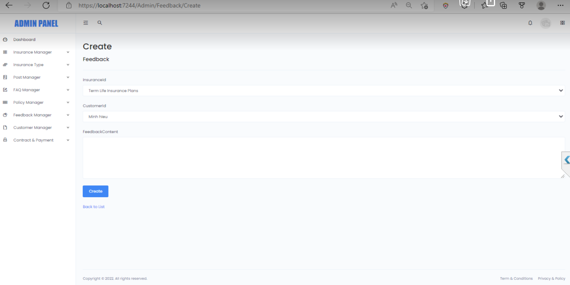

|  |  |  |  |  |  |  |
| --- | --- | --- | --- | --- | --- | --- |
| **No** | **Name** | **Type** | **Validation** | **Event** | **Description** | **Status** |
| 1 | Insurance ID | Select | -Not null | Click | Input: Insurance ID | Enable |
| 2 | Name | Text Box | -Not null | Click | Input: Name | Enable |
| 3 | Description | Text Box | -Not null | Click | Input: Description | Enable |
| 4 | Create | Hyperlink |  | Click | Click to submit create Insurance | Enable |

**2.23 Update new feedback**

**2.24 Customer manager**

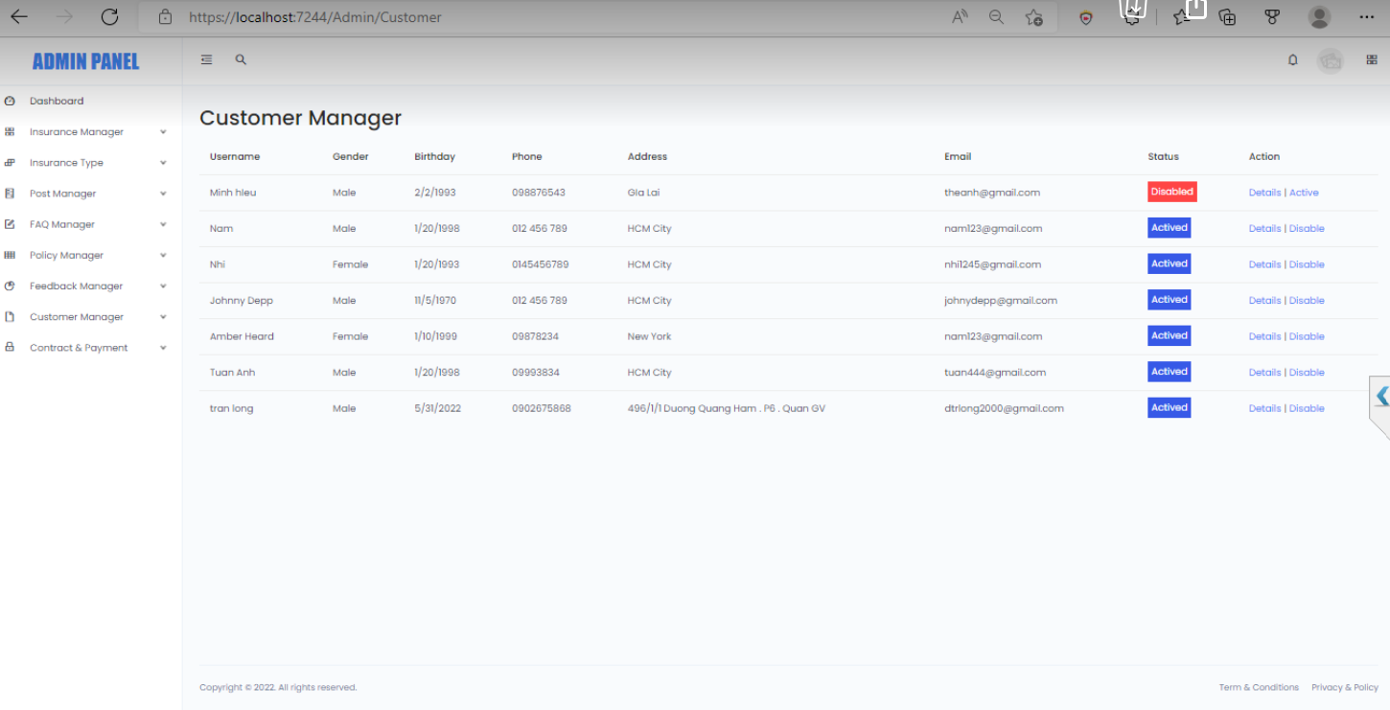

|  |  |  |  |  |  |  |
| --- | --- | --- | --- | --- | --- | --- |
| **No** | **Name** | **Type** | **Validation** | **Event** | **Description** | **Status** |
| 1 | Status | CheckBox |  |  | Show Status Customer | Enable |
| 3 | Details | Button |  | Click | Show detail Customer | Enable |
| 3 | Active | Button |  | Click | Check active/disable Customer | Enable |

**2.25 Edit Customer**

**2.26 Contract & payment**

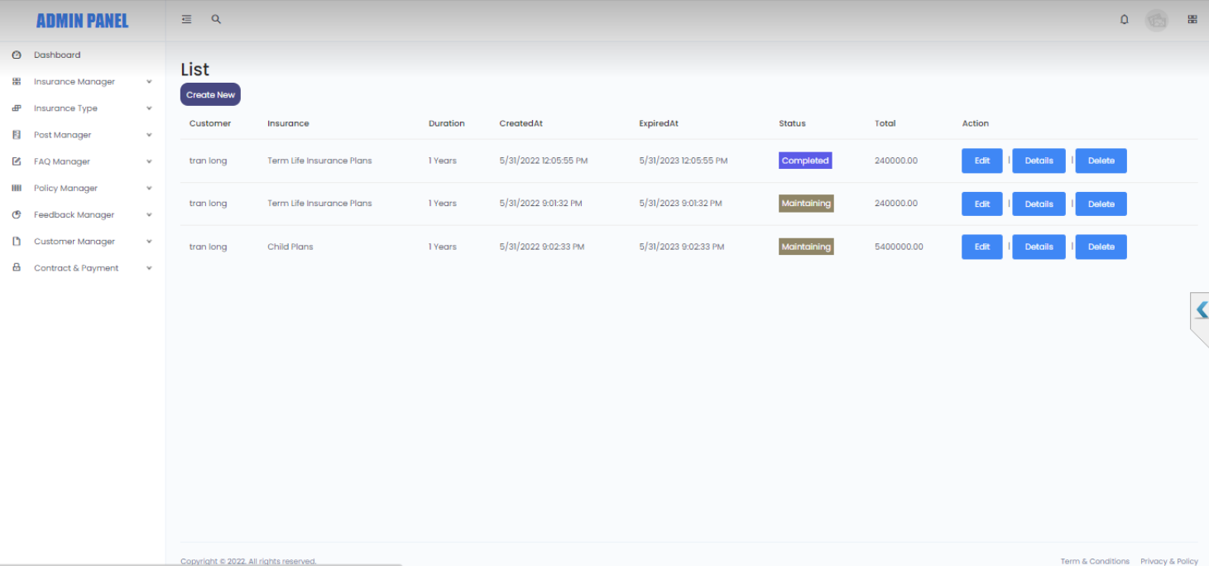

|  |  |  |  |  |  |  |
| --- | --- | --- | --- | --- | --- | --- |
| **No** | **Name** | **Type** | **Validation** | **Event** | **Description** | **Status** |
| 1 | Edit | Button |  | Click | Edit to Contract & Payment | Enable |
| 3 | Details | Button |  | Click | Show detail Contract & Payment | Enable |
| 3 | Delete | Button |  | Click | Remove to Contract & Payment | Enable |

**2.27 Update contract & payment:**

